Hardware: Processing
hw_processing.php — Hardware
Quotes….
If it draws blood, it's hardware.
– Anonymous

Hardware: This is the part of the computer that stops working when you spill beer on it.
– Dave Barry Photo by Charlie Cowins from Belmont, NC, USA (famous author Dave Berry) [CC BY 2.0 ], via Wikimedia Commons
Those parts of the system that you can hit with a hammer are called hardware;
those program instructions that you can only curse at are called software.
– Anonymous
Hardware: where the people in your company's software section will tell you the problem is.
Software: where the people in your company's hardware section will tell you the problem is.
– Dave Barry Photo by Charlie Cowins from Belmont, NC, USA (famous author Dave Berry) [CC BY 2.0 ], via Wikimedia Commons

The inside of a computer is as dumb as hell but it goes like mad!
– Richard FeynmanPhoto from Wikipedia

(The CPU)… takes these very simple-minded instructions:
'Go fetch a number, add it to this number, put the result there, perceive if it's greater than this other number' - but executes them at a rate of, let's say, 1,000,000 per second.
At 1,000,000 per second, the results appear to be magic.
– Steve JobsPhoto by Matthew Yohe [CC BY-SA 3.0 or GFDL], via Wikimedia Commons

Moore’s law, prediction made by American engineer Gordon Moore in 1965 that the number of transistors per silicon chip doubles every year
(later adjusted to 18 months / 2 years - this implies that processing power doubles during that time)
– Gordon Moore Photo by Science History Institute [CC BY-SA 3.0 ], via Wikimedia Commons

Moore’s law is astonishing, it’s beyond belief, it’s the dynamo of the modern age.
– Alvy Ray SmithPhoto by Alvy Ray Smith [CC BY-SA 3.0 ], from Wikimedia Commons

Men and machines are good at different things.
People form plans and make decisions in complicated situations. We are less good at making sense of enormous amounts of data.
Computers are exactly the opposite: they excel at efficient data processing but struggle to make basic judgments that would be simple for any human.
– Peter ThielPhoto by Dan Taylor [CC BY 2.0 ], via Wikimedia Commons
(The mouse)… is going to be the primary interface of the computer of the future.”
– Steve JobsPhoto by Matthew Yohe [CC BY-SA 3.0 or GFDL], via Wikimedia Commons
There is no reason for any individual to have a computer in his home.
– Ken Olsen (1977)

Truth is, I wouldn't know a gigabyte from a snakebite.
– Dolly PartonPhoto - Public domain from Wikipedia
We're going to be able to ask our computers to monitor things for us, and when certain conditions happen, are triggered, the computers will take certain actions and inform us after the fact.
– Steve JobsPhoto by Matthew Yohe [CC BY-SA 3.0 or GFDL], via Wikimedia Commons

I think it's pretty pointless, my children learning to use a keyboard - we will just talk to our computers. Why would we not?
– Julian TreasurePhoto from Flikr
Virtual reality is Silicon Valley’s next new thing. Facebook and Google (not to mention Microsoft) are making huge bets on the technology and battling to control its future.
Hollywood has jumped on the bandwagon, too: The best VR content is now showcased every year at the Sundance Film Festival.
– Adam Fisher

The microprocessor is a miracle.
– Bill Gates Photo by DFID - UK Department for International Development (https://www.flickr.com/photos/dfid/14590135480/) [CC BY 2.0], via Wikimedia Commons
Every one of today's smartphones has thousands of times more processing power than the computers that guided astronauts to the moon.
– Peter ThielPhoto by Dan Taylor [CC BY 2.0 ], via Wikimedia Commons
As the world transitions to the Internet of Everything - where people, processes, and data are intelligently connected - we'll be linked in even more ways.
Here, billions and trillions of sensors around the earth and in its atmosphere will send information back to machines, computers, and people for further evaluation and decision-making.
– Tae Yoo
640 kb (of memory) ought to be enough for anybody…
– Bill Gates - 1981 (disputed - he claims he never said it) Photo by DFID - UK Department for International Development (https://www.flickr.com/photos/dfid/14590135480/) [CC BY 2.0], via Wikimedia Commons

Computers may save time but they sure waste a lot of paper. About 98 percent of everything printed out by a computer is garbage that no one ever reads.
– Andy RooneyPhoto by Stephenson Brown (originally posted to Flickr as IMG_1902) [CC BY 2.0 ], via Wikimedia Commons

By 2020, most home computers will have the computing power of a human brain.
That doesn't mean that they are brains, but it means that in terms of raw processing, they can process bits as fast as a brain can.
So the question is, how far behind that is the development of a machine that's as smart as we are?
– Seth ShostakPhoto by Seth Shostak [CC BY-SA 4.0 ], from Wikimedia Commons
On my desk I have three screens, synchronized to form a single desktop. I can drag items from one screen to the next. Once you have that large display area, you'll never go back, because it has a direct impact on productivity.
– Bill Gates Photo by DFID - UK Department for International Development (https://www.flickr.com/photos/dfid/14590135480/) [CC BY 2.0], via Wikimedia Commons
When you want to do your homework, fill out your tax return, or see all the choices for a trip you want to take, you need a full-size screen.
– Bill Gates Photo by DFID - UK Department for International Development (https://www.flickr.com/photos/dfid/14590135480/) [CC BY 2.0], via Wikimedia Commons
I/O, I/O, It's off to disk I go, A bit or byte to read or write, I/O, I/O, I/O...
– Author Unkown (sung to the tune of "Hi Ho" from Disney's Snow White and the Seven Dwarves)

A computer terminal is not some clunky old television with a typewriter in front of it. It is an interface where the mind and body can connect with the Universe and move bits of it about.
– Douglas AdamsPhoto by Douglas_adams_portrait.jpg: michael hughes from berlin, germanyderivative work: Beao (Douglas_adams_portrait.jpg) [CC BY-SA 2.0 ], via Wikimedia Commons
Like car accidents, most hardware problems are due to driver error.
– Author Unkown
A printer consists of three main parts: the case, the jammed paper tray and the blinking red light
– Author Unkown
RAM /abr./: Rarely Adequate Memory.
– Author Unkown

The future lies in designing and selling computers that people don't realize are computers at all.
– Adam OsbornePhoto from Wikimedia Commons

More than any other modern tool, computers are a total mystery to their users. Most people never open them up to fix them or to see how they work.
– Clive ThompsonPhoto from Flikr

Processing, Memory & GPUs


Getting the work done - the CPU (and GPU) and Memory
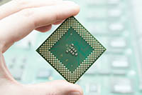
Not so long ago the immediate answer to the question of
What does all the work in a computer?
was simply
The CPU.
Today it is not so simple.
The
GPU
is being used for far more than just rendering graphics. A GPU is designed to do a lot of mathematical calculations in parallel (the calculations happen at the same time) - because that is what is needed to render 3D graphics.
This can be very useful for applications that need to do a lot of mathematics. These programs check if there is a GPU installed and then send the heavy maths part of the work they do off to the GPU and let the CPU work on the rest. This obviously improves the performance of the software.
You can check if a program uses this feature by looking for the words
GPU Acceleration
somewhere in its description.
GPU accelerated programs will still work without a GPU - they'll just be slower.
The CPU & the SoC
CPU & SoC
CPU stands for Central Processing Unit.
SoC stands for System On a Chip.
You will find a CPU in laptops and desktops.
The main manufacturers of CPUs are:
Intel
AMD
Apple
The CPU is difficult to see in most computers as it is hidden below a cooling fan & heat sink.
A SoC is most likely to be found in mobile devices and embedded devices - the exception is Apple's M series of SOC found in desktops and laptops as well..
Warning:
People often just say CPU or processor instead of SoC (it's easier to say and, after all, the SoC includes a CPU) - so the terminology can be a bit confusing.
The difference is that a CPU is designed to fit into a motherboard and be upgradeable / replaceable, whilst a SoC by its very design can't be used that way.
A SoC, is a chip that has most (if not all) of the following included in it:
CPU
GPU
Memory
Storage
I/O (Usb controllers, etc)
Wireless controller
Cellular Radio controller
As you can imagine, cramming all of these functions onto a single chip:
saves a huge amount of space (its the only reason our mobile devices can be so small and thin)
reduces costs
reduces power consumption
makes upgrading / repair almost impossible
The main manufacturers of SoCs are:
Apple
Qualcomm
Samsung
ARM
is a company that designs these SoC types of processors but does not make them. Instead it sells licenses for its designs to companies such as QualComm and Samsung who make their own changes and then manufacture the processors.
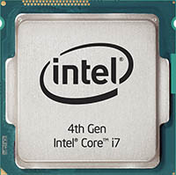
[image unavailable: Stacks Image 4576]
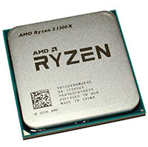
Desktop CPUs by intel, Apple and AMD
Mobile SoCs by Apple and Qualcomm
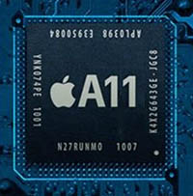
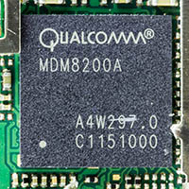
Back to the top of this Panel
CPU Core count

What does x Core mean?
[image unavailable: Stacks Image 4573]
The x in 'x core' stands for the number of physical CPUs included on a single chip.
A 2 Core chip is the same as if you had a motherboard with 2 CPU sockets and put 2 single core CPUs into that motherboard.
It's like if your head is the chip and the CPU is the brain - with 2 cores you could fit two brains inside your head!
A 4 Core CPU has 4 separate processors included in a single chip.
The highest core count (in 2018) for a single CPU is 32.
That is 32 processors on a single chip!
A high end CPU like this costs around R30 000.
Back to the top of this Panel
What a CPU Does

What a CPU does
A simplified explanation of what a CPU does is:
Fetch an instruction from RAM
Remember, all programs and data have to be loaded into RAM before the CPU can work with them.
Decode the instruction
Sometimes the instruction may contain multiple parts - for example an instruction to load data will have two parts - the 'load' instruction followed by the address in memory that the data must be fetched from.
Execute the instruction
The instruction may be only to fetch data from memory - or save data to memory.
The CPU does this sequence over and over again - at an incredible speed (billions of these steps in a second).
The speed of CPUs is measured in Ghz
(GigaHertz: 1 GigaHertz = 1 billion cycles per second).
Note that a single instruction for the CPU may take more than 1 cycle to complete, so it is incorrect to say that 1 Ghz = 1 billion
instructions
per second).
Back to the top of this Panel
Returm to the top of the Dropdown List
Memory - RAM
RAM - The Basics
RAM stands for Random Access Memory
RAM is also known as the 'working memory' of the computer. Other names for RAM include Primary Memory, Working Storage, Working Memory, Primary Storage.
Any program that the computer is running - and the data for these programs MUST be loaded into RAM for the CPU to access it / work on it.
You will find separate RAM modules in desktops and laptops. This means that you can replace faulty RAM or upgrade the RAM in these devices.
In mobile devices the SoC has the RAM built into it. You are always stuck with the amount of RAM the device had when you bought it.
Video Cards (also called GPUs because people are lazy, though the GPU is actually only the processing chip on the card) also have their own memory. This memory is built into (soldered onto) the board and can not be upgraded by the user.
RAM comes in 'sticks' - small boards called
DIMMS
(Dual Inline Memory Modules) that fit into the RAM slots on the motherboard.
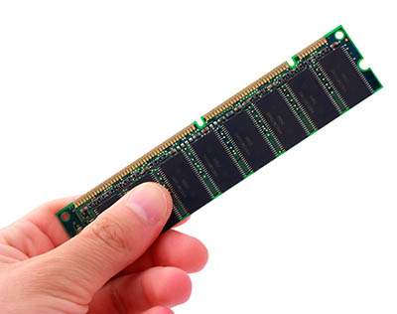
A single 'stick' of RAM. These DIMMs can also come in larger packages with RGB lighting and their own heat sinks.
Note the holes / grooves on the connection edge. These make sure that you can only put the RAM into the slots on the motherboard the right way around.
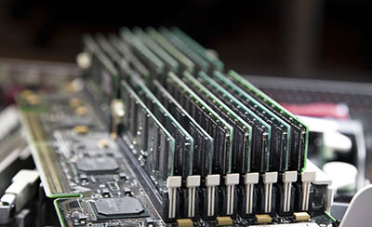
The RAM DIMMs fit into slots on the motherboard. The number of slots physically limits the amount of RAM you can put into your computer.
The DIMM must be pushed firmly into the slot and held in place by the clamps on either side of the slots.
Back to the top of this Panel

Characteristics of RAM
RAM is
Electronic (solid state)
Ram is electronic or 'solid state'. This means it has no mechanical moving parts.
Fast
The fact that RAM is electronic also means that RAM is fast - it operates at the speed of electricity.
Expensive
How expensive? Less expensive than cache (but then you don't buy cache directly - cache is included on your CPU.
The only way yo understand how expensive RAM is compared to storage - and we'll do that a little later…
Volatile
The way that RAM is designed means that it needs a constant supply of electricity to work.
If that electricity is interrupted for a moment then the RAM will reset itself and lose all the data it was holding.
When an app is closed (i.e. you quit the app) or when an app crashes without the data being saved, the data will also be lost.
Back to the top of this Panel
Memory vs Storage

(click for the answer)

What's in a name? Memory vs Storage
We call RAM memory - but do not be surprised if you see articles on the web that refer to RAM as storage. This is because RAM holds data just like a hard drive, flash drive, SSD or CD does.
In the same way you will also find articles on the web that call hard drives, flash drives, SSDs etc 'memory'.
People who call RAM storage generally refer to it as working storage or primary storage as a way to differentiate between RAM and hard drives, etc.
Those that call hard drives etc 'memory' will usually call them 'long term memory' or 'secondary memory'.
All of that can be confusing, which is why we stick to 'memory' for RAM and 'storage' for hard drives, flash drives, SSDs, etc.
Back to the top of this Panel
Cost of RAM

Is RAM really so expensive?
Complete the exercise below (both columns) before revealing the hidden content in the next paragraph….

Memory
Visit EveTech / Loot / ComputersOnly / WootWare (or your favourite online computer hardware store).
Find a RAM product that you would like to install in your computer.
What is the price of the RAM?
(enter the numbers only)
Cost of RAM
What is the capacity of the RAM in Gb?
(enter the numbers only)
Capacity of RAM
Divide the cost (R [rcost]) by the capacity ([rsize] gb).
What do you get?
Cost / Gb
So:
[rsize] gb of RAM costs R [rcost].
This works out at R [rcalc] per gigabyte (according to your calculations).
If you haven't done so already, do the same for storage in the clock next door - and compare the results.
Click here to edit text.

Storage
Visit EveTech / Loot / ComputersOnly / WootWare (or your favourite online computer hardware store).
Find a storage product that you would like to install in your computer.
What is the price of the storage?
(enter the numbers only)
Cost of storage
What is the capacity of the RAM in Gb (remember 1 Tb = 1000 Gb)?
(enter the numbers only)
Capacity of storage
Divide the cost (R [scost]) by the capacity ([ssize] gb).
What do you get?
Cost / Gb
So:
[ssize] gb of Storage costs R [scost].
This works out at R [scalc] per gigabyte (according to your calculations).
If you haven't done so already, do the same for storage in the clock next door - and compare the results.
Click here to edit text.

So is RAM expensive?
Think about the results of the exercise above, draw your own conclusion and then click to reveal the answer below…
YES, RAM is expensive!
If you take the cost of a stick of RAM and divide it by its capacity (its size in Gb) then you have worked out the cost / Gb of that particular type of memory / storage.
If you do the same for a hard drive / flash drive / SSD then you will see that RAM is far more expensive than any other type of storage / memory.
Back to the top of this Panel
Different Types of RAM

Different types of RAM
You get TWO different types of RAM - DDR x and ECC.
NB: They look almost the same (except that DDR usually has an even number of chips - usually 8 - and ECC has an uneven number - usually 9), so it is difficult to tell them apart visually.
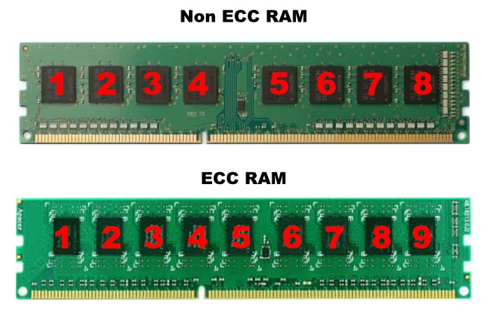
DDR x
Double Data Rate memory
- t
he x can be 2, 3 or 4.
The higher the number the faster the RAM transfers data.
NB
: You have to make sure that your motherboard supports the type of RAM you want to put into it.
For example, you can't use DDR 4 RAM on a motherboard that only supports DDR3 RAM.
ECC
Error Correcting Code memory
This type of memory is more expensive and generally only used in servers / high end workstations.
This type of RAM can detect if there is an error in the data it stores / is receiving and can correct the error.
Back to the top of this Panel
RAM of the Future

RAM of the FUTURE
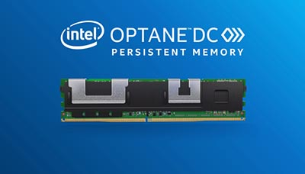
New on the market (2019) is Intel's Optane memory. This RAM is actually non volatile - it uses the same type of technology as SSDs - except faster. Optane memory promises large amounts of RAM (hundreds of gigabytes) that does not lose its contents.
Imagine: you can switch your computer off and when you switch it back on it will not have to boot and all your apps & their data will be exactly as they were when you switched off!
This type of memory blurs the lines between memory and storage and if it succeeds will change the way we talk about these concepts in the future.
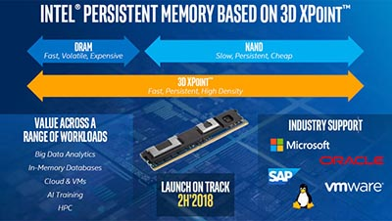
Back to the top of this Panel
The GPU
GPU stands for Graphics Processing Unit.
GPUs are technically the processing component on Video Cards but most people just call the whole card a GPU.
A GPU is an expensive optional component found in computers designed and built for CAD, 3D graphics, Video editing and gaming. A high-end workstation class GPU can cost over R100 000 whilst a top level gaming GPU will cost between R20 000 - 30 000.
GPUs plug into PCIe slots on the motherboard. They have their own fans to keep themselves cool. They draw a lot of power - so if you want to add a GPU to your computer then you need to make sure that your power supply can cope with the extra load.
The two main manufacturers of GPUs are:
- nVidia
- AMD
The GPU is designed to process huge amounts of data in parallel doing mainly floating point arithmetic.
The design of the GPU means that some programmers have decided to use it not only to create graphics for the screen but also to do heavy number crunching work that the cPU would normally have to do - letting the cpu focus on other tasks and speeding up the performance of the system overall.
Only programs that boast that they are 'GPU accelerated' can use this feature.
In some cases GPU acceleration is limited to computers using nVidia graphics cards because the programmers have focussed on using the API for nVidias CUDA technology - this is specifically true for many 3D graphics tools such as Daz 3D, Cinema 4D, Maya, etc.
The fact that the GPU can do some of the processing work means that it is not longer true to say that the CPU does all the work in the computer.
GPUs have their own memory - anything from 2 - 16 Gb per GPU.

External GPUs
GPUs transfer and work with large amounts of data at once. This means that they have only been designed to plug into PCIe slots in a motherboard and it has not been possible to add a GPU to a computer as an external peripheral.
Thunderbolt 2 & Thunderbolt 3 technology allows for a high enough data transfer rate to make this possible.
You can buy enclosures that have PCIe slots in them that connect to your computer using Thunderbolt. You can then plug a video card into the enclosure, plug in the thunderbolt cable, install the drivers and you have added a GPU to your computer without opening the case!
This makes it possible to add a GPU to a laptop which would otherwise be unable to upgrade its graphics system!
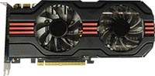
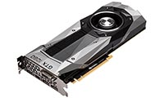
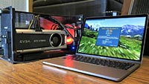
Returm to the top of the Dropdown List

Video Links - Processing
We have selected and curated a set of videos on YouTube related to your course.
These videos are not created or owned by us.
They may display advertising and in some cases may contain limited amounts of swearing.

Notes for this Module
What to look out for and do in this module...

FAQs for this module
Questions on CPUs, RAM, ROM and GPUs - and their answers...

Network Types FAQ
View the questions or type in the term you are looking for below…
No results were found

What is the difference between a CPU and a SOC?
The CPU is designed to plug into a motherboard that allows it to connect to memory, storage, GPU, etc.
A SOC is a complete system on a single chip that includes CPU, memory, storage, GPU, etc. on one single chip. CPUs are used in desktops and laptops. SOCs are used in mobile devices and embedded computers.

Is it true that only the CPU does the work in a computer?
The answer is mostly yes. The problem is modern GPUs are powerful calculation machines that can do more than just render graphics to display on your screen.
If you have a GPU and you have the right type of software then that software can use the GPU to do some of the processing work to speed up your computer's performance.

Can you have more than one GPU?
Yes!
Many GPUs can be paired up to work together (as long as they are the same make and model). You can even have GPUs from different manufacturers in the same computer. My Mac Pro has two built in AMD graphics cards and a separate external NVidia GPU to help speed up 3D rendering.

What is the difference between Multi-core CPUs and Hyper-threaded CPUs?
Multi-core means that there is more than one physical CPU on a single chip
Hyper-threading is when each physical CPu presents itself to the OS as two virtual CPUs. The result is that if you have a Quad Core Hyper-threaded CPU the OS thinks it has 8 CPUs to split the processing tasks between.

Is more cores always faster / more powerful?
The answer is NO.
Your computer is running one task only and the lower core count CPU has a faster clock speed then this cpu will perform better than a CPU with more cores but a lower clock speed. The fact is that multi-core is designed for programs that can use more than one core at a time - or for people that run many programs at once. In this situation a higher core count will always beat a lower core count.

How much RAM is enough?
The answer is - it depends…
I am a heavy multi-tasker and have multiple apps open at once. For example as I type my system is running Affinity Designer, Photoshop, Pixave, RapidWeaver, Safari (with around 60 tabs open), ImageOptim, Chronosync, Transmit, PDF viewer, Kindle ereader, iTunes, iBooks, Airmail, Billings Pro and MS Word. That's a lot of apps! My system has 32Gb RAM and performs well under almost any load I can throw at it. So for me, 32 Gb is enough. If you do not do heavy multitasking I imagine you should be able to get away with 16 Gb of RAM. This should also be enough for the most avid gamer If you only use your computer for basic productivity tasks then 8Gb should be enough. I would not go lower than that.

Which is better AMD or Intel?
The answer will always be…
it depends on your personal preference and your own sense of value for money.
it depends on your personal preference and your own sense of value for money. If you are working in 3D more software uses nVidia's CUDA processing technology to help your CPU render your 3d graphics.

Which is better AMD or nVidia GPUs?
The answer will always be…

